**Assignment 3**

1. **Create table dept with the following attributes (Add constraints during creation of the table):**

**Column name Data type(size) Constraints**

**dept_id number(3) primary key**

**dept_name varchar2(10)**

create table dep (dep_id number(3) not null,dep_name varchar2(10),primary key(dep_id));

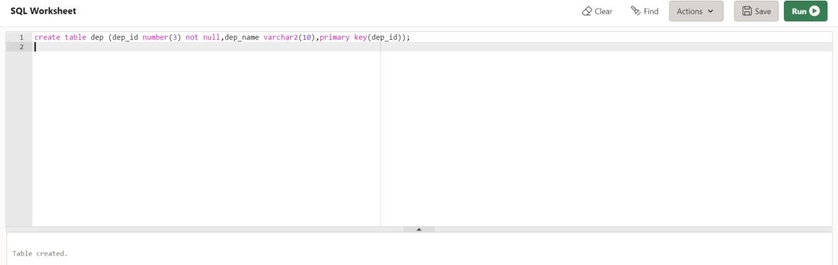

1. **Insert 4 department records with names and id's 90, 69, 100 and 110.**

insert into dep values(90,'CSE');

insert into dep values(69,'IT');

insert into dep values(100,'EE');

insert into dep values(110,'ECE');

select * from dep;

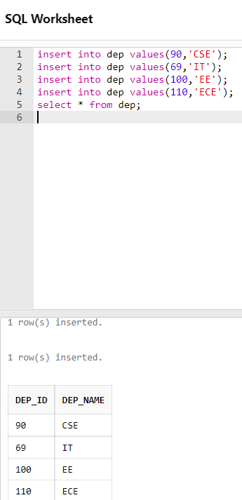

1. **Create table Student with the following attributes(Add constraints during creation of the table) :**

**Column name Data type(size) Constraints**

**stud_id number(3) primary key**

**name varchar2(15)**

**marks number(5,2)**

**Dept_id number(3) foreign key refers to dept**

create table Student (stud_id number(3) not null,name varchar2(15),marks number(5,2),dep_id number(3),primary key(stud_id),foreign key (dep_id) references dep (dep_id));

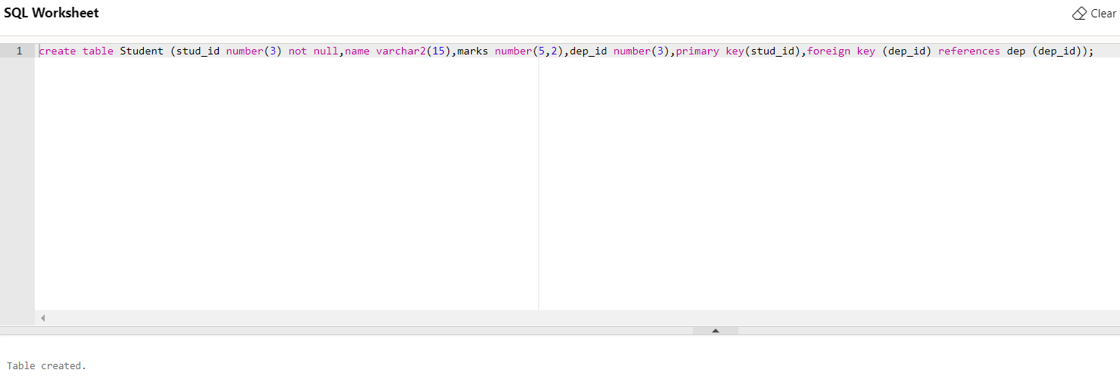

1. **Insert 4 student records.**

insert into Student(stud_id,name,marks,dep_id)values('1','Suvodeep','57','90');

insert into Student(stud_id,name,marks,dep_id)values('2','Didhiti','88','69');

insert into Student(stud_id,name,marks,dep_id)values('3','Amlan','94','100');

insert into Student(stud_id,name,marks,dep_id)values('4','Sahin','45','110');

select * from Student;

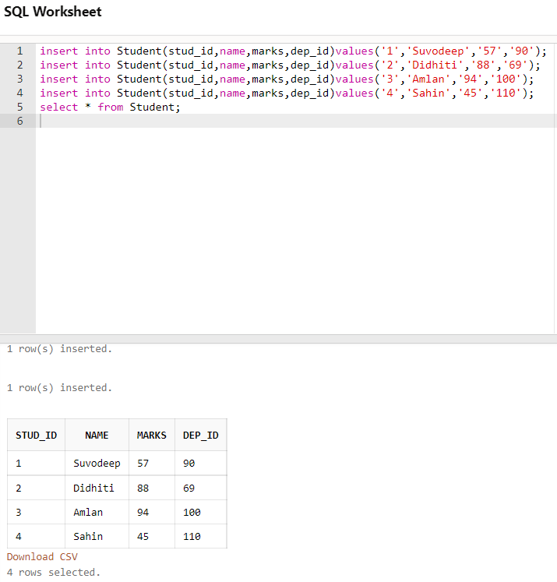

1. **Insert a record in the student table with dept_id 50**

insert into dep(dep_id,dep_name)values('50','IOT');

insert into Student(stud_id,name,marks,dep_id)values('5','Peter','54','50');

select * from Student;

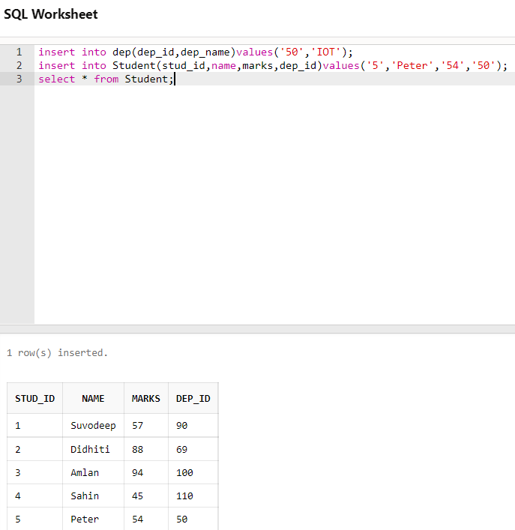

1. **Display the name and marks of the students whose name contain at least one ‘d’. [using like]** select name,marks from Student where name like '%d%';

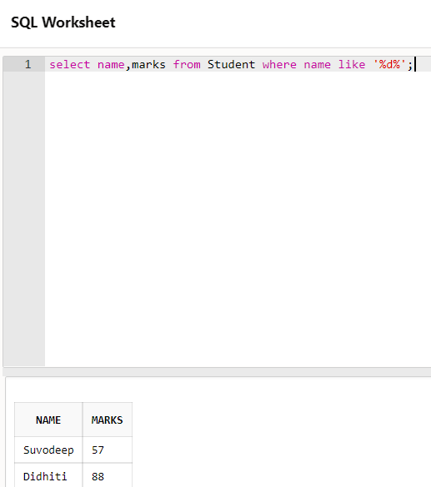

1. **Create table cust100 with the following attributes (Add constraints after creating the table):**

create table cust100(emp_id number(3) not null,first_name varchar2(10),last_name varchar2(10),e_mail varchar2(20),ph_no varchar2(15),hire_date date,job_id varchar2(10),salary number(8,2),mgr_id number(3),dep_id number(3),primary key (emp_id),foreign key (dep_id) references dep(dep_id));

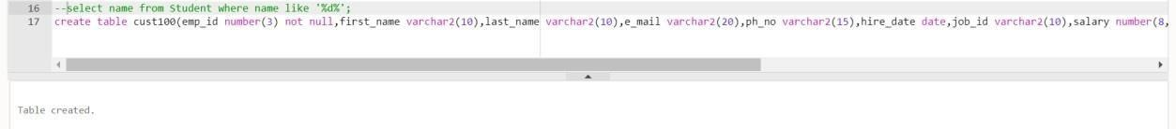

1. **Add 6 records to cust 100:**

insert into cust100 values(1,'mitali','singh','mitali90@gmail.com','9065123105','25-AUG-11

','11',50000.00,111,90); insert into cust100 values(2,'ayushi','shriwastav','ayshi88@gmail.com','9064567105','2-OCT-

10','22',55000.00,222,100); insert into cust100 values(3,'gaurav','muskan','musgavi58@gmail.com','9864567105','2-DEC-1

3','33',66000.00,333,110); insert into cust100 values(4,'muskan','singh','muskan98@gmail.com','9864567896','22-DEC-13

','33',69000.00,444,110); insert into cust100 values(5,'nikhil','kumar','kumar00@gmail.com','9861234896','22-FEB-

10','55',70000.00,555,90); insert into cust100 values(6,'bhawesh','kumar','bhawesh23@gmail.com','8872234896','22-JUN-

11','55',60000.00,666,100); select * from cust100;

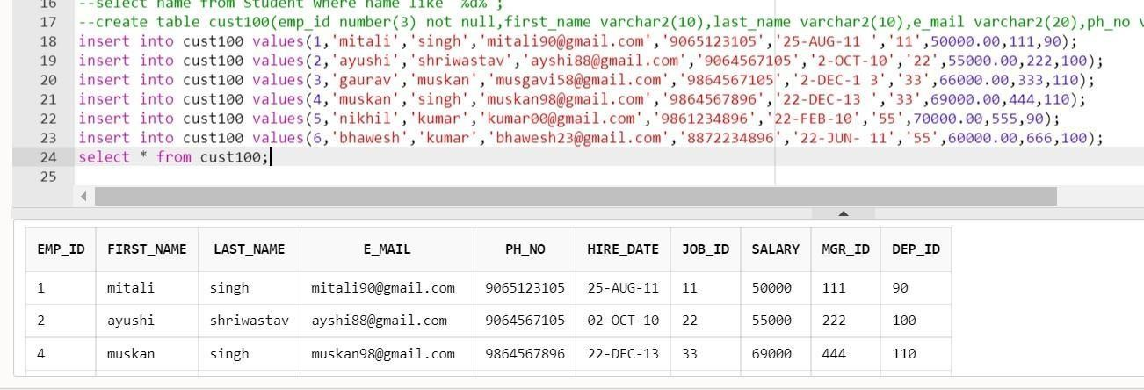

9. **Drop column mrg_id**

alter table cust100

drop column mgr_id; select * from cust100;

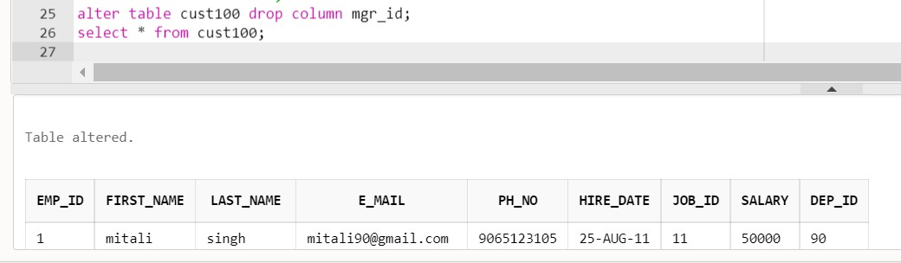

**ASSIGNMENT 2**

**16. From ‘employees’ table display email and domain separately.**

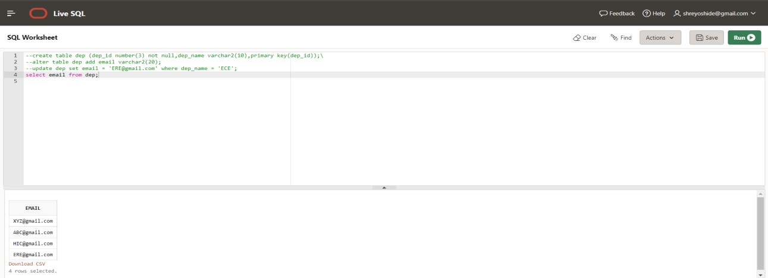

SELECT SUBSTRING ([email], CHARINDEX( '@', [email]) + 1,

LEN([email])) AS [Domain]

FROM [dep];

